ASSIGNMENT 06

Q1Write two diff queries that would produce all orders taken on october 3rd or 4th,1990
Ans.
1st query

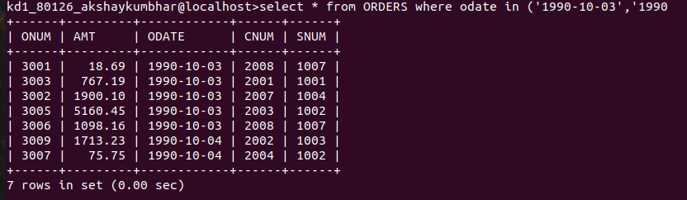

2nd query
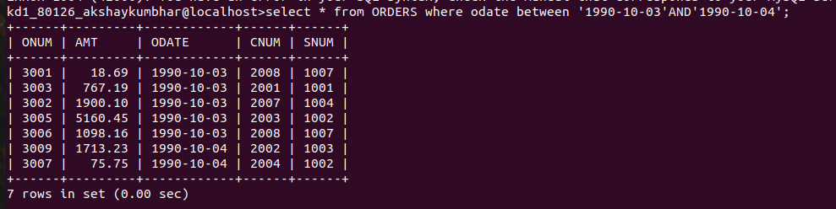
Q2.Write a query that selects all of the customers serviced by peel or motika.
Ans.

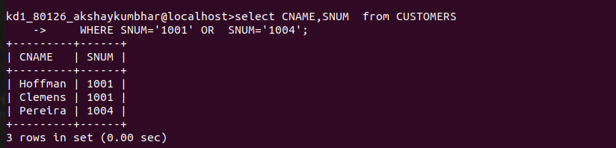

Q3.Write a query that will produce all the customers whose names begin with a letter from ‘A’ to ‘G’.
Ans.
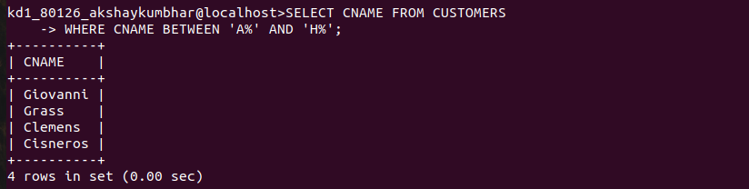

Q4.Write a query that selects all customers whose names begin with the letter ‘c’.
Ans.

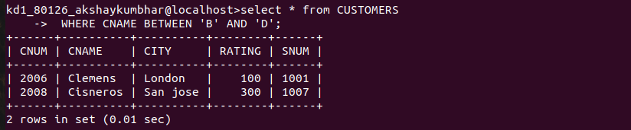

Q5.Write a query that selects all orders except those with zeroes or NULLs in the amt field.
Ans.
